Task Description#1

● Zero-shot: Prompt AI to write a function that checks whether a given year is a leap

year. give prompt

prompt : Write a function in Python that takes a year as input and returns True if it is a leap year and False otherwise

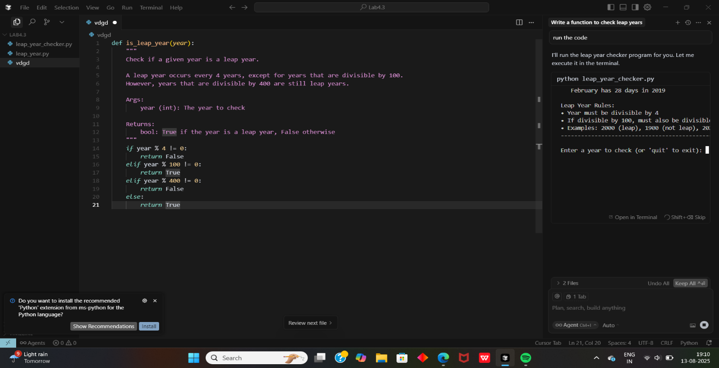

Task Description#2

● One-shot: Give one input-output example to guide AI in writing a function that

converts centimeters to inches

Prompt : Write a Python function that converts a length in centimeters to inches. For example, if the input is 10, the output should be 3.937.

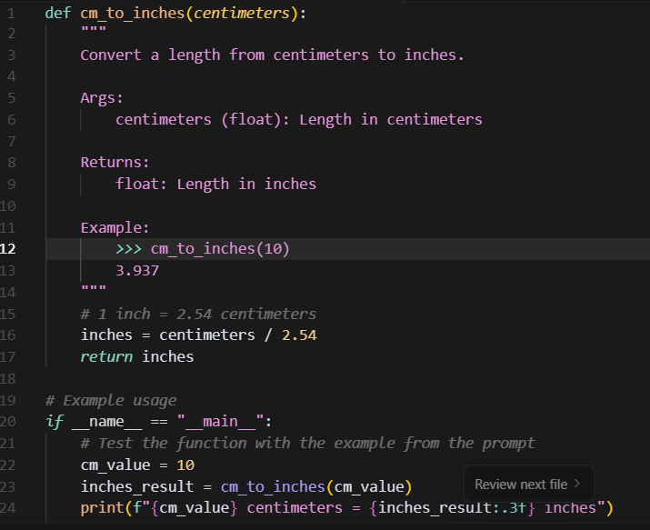

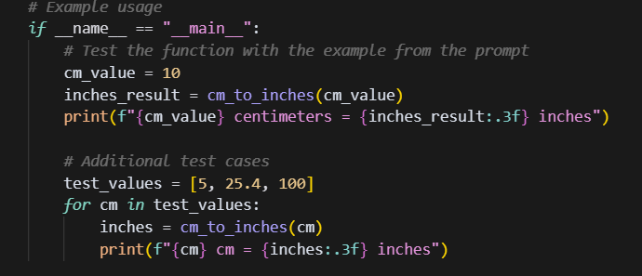

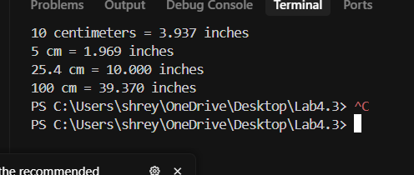

Task Description#3

● Few-shot: Provide 2–3 examples to generate a function that formats full names as

“Last, First”.

Write a Python function that takes a full name in the format First Last and returns it in the format .Last, First.

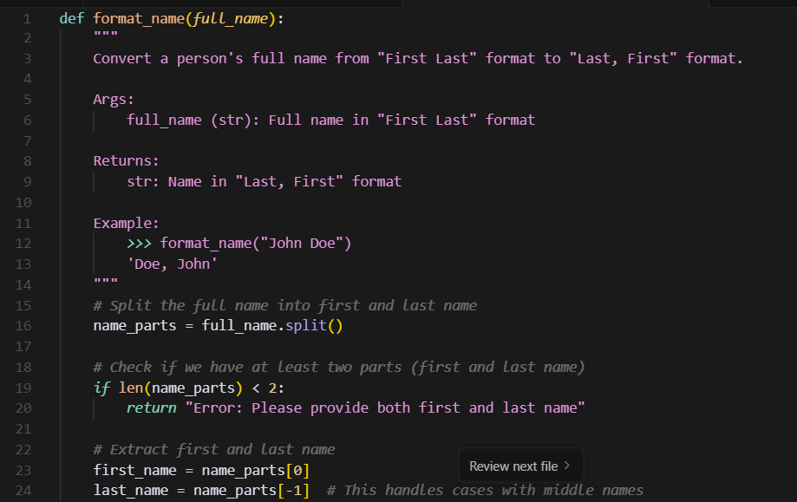

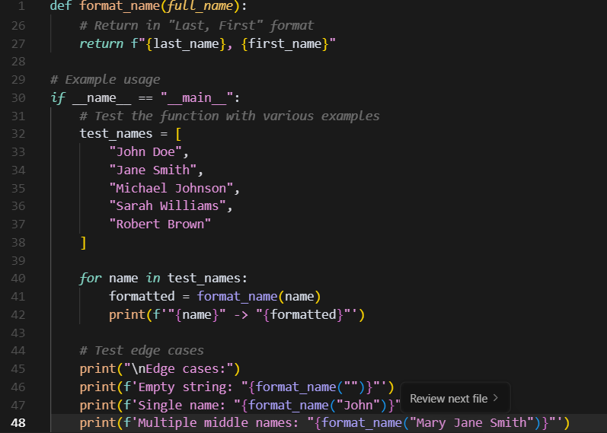

#Output:

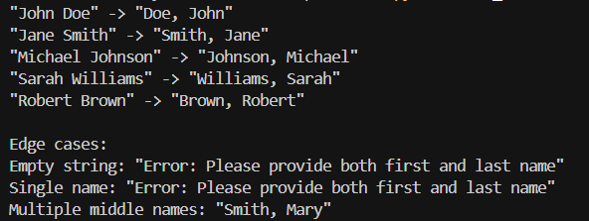

Task Description#4

● Compare zero-shot and few-shot prompts for writing a function that counts the

number of vowels in a string

Prompt : **Zero-shot Prompt**

Write a Python function that takes a string as input and returns the number of vowels in the string.

Few-shot Prompt

Write a Python function that takes a string as input and returns the number of vowels in the string.

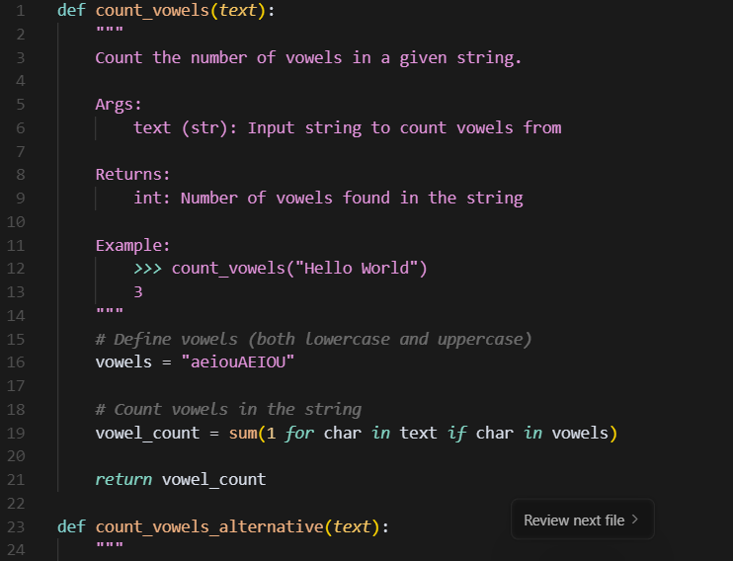

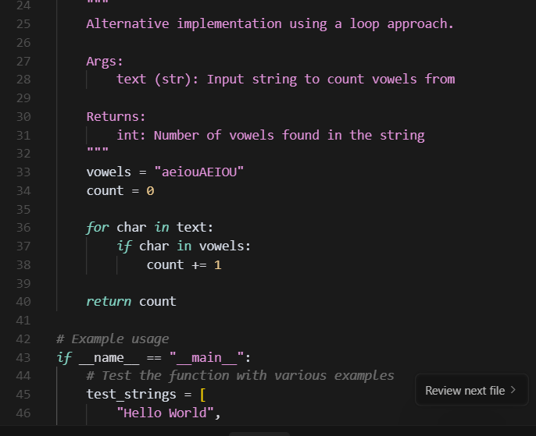

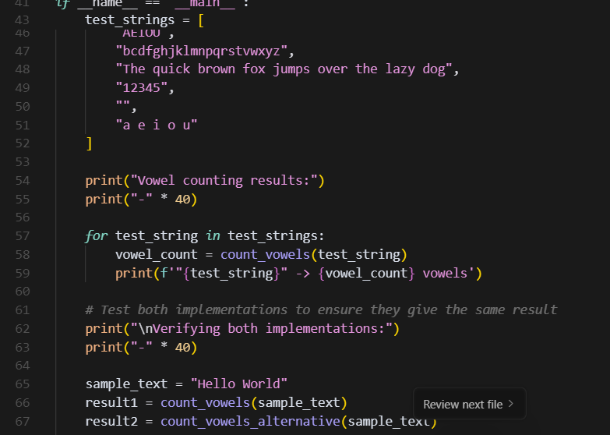

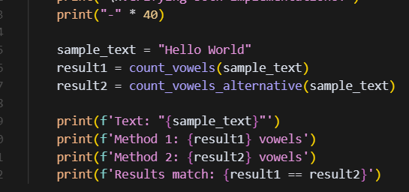

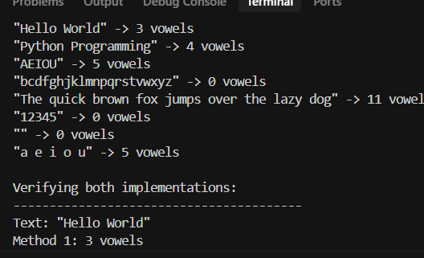

Task Description#5

● Use few-shot prompting to generate a function that reads a .txt file and returns the

number of lines.

Prompt : Write a Python function that takes the path to a .txt file as input and returns the number of lines in that file

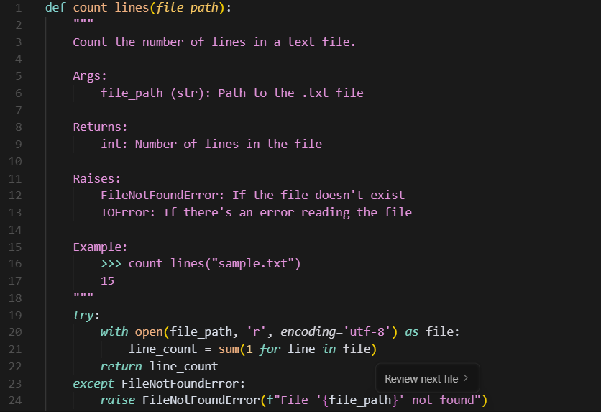

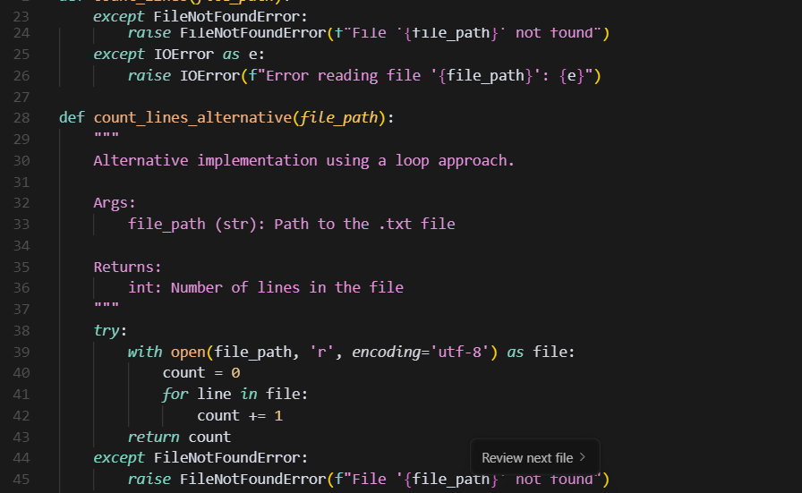

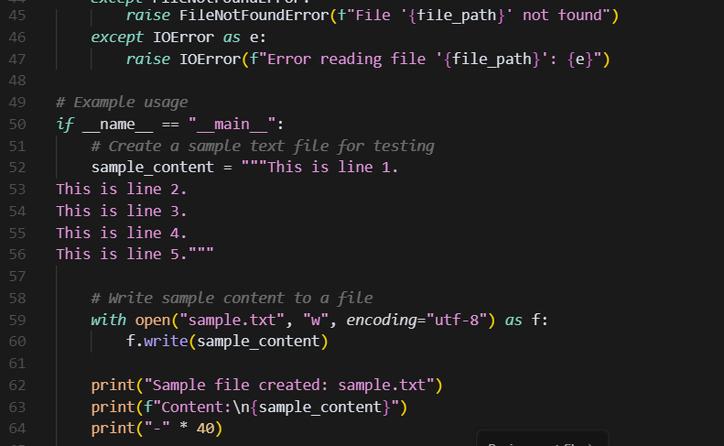

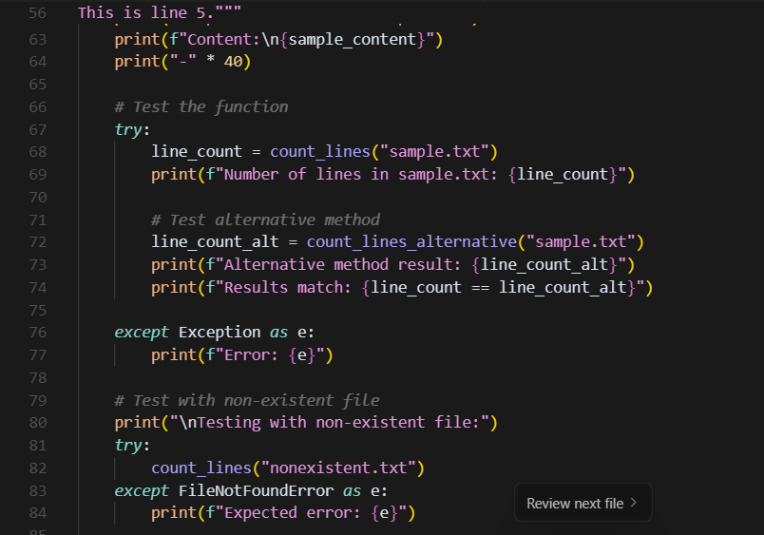

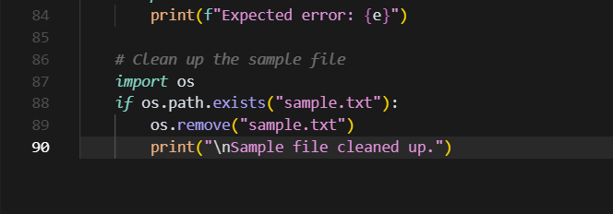

#Output:

